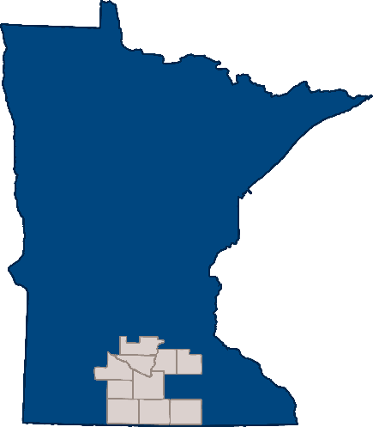
South Central Community Based Initiative
Joint Powers Board Meeting Minutes
1/19/2024

Location: Blue Earth County Government Center, 410 South 5th St, Mankato MN 56003
Attendance
Voting: ☒Anne Broskoff, Brown County ☒Phil Claussen, Blue Earth County
☒Chera Sevcik, Faribault/Martin County ☒Suzi Nerison, Freeborn County
☒Jamie Hayes, Le Sueur County ☒Cassie Sassenberg, Nicollet County ☒Megan Thomas, Rice County
☒Klea Rettman, Sibley County ☒Amy Pluym, Watonwan County
Non-voting: ☒Angela Youngerberg, Blue Earth County (Delegate)
☒Anna Garbers, Faribault/Martin County (Delegate) ☒Chris Sammon, Rice County (Delegate)
☒Amy Haas, Consumer Representative ☒Ricki Pribyl, Regional Manager
☐RMT Representative:Click or tap here to enter text.
☒Children’s Cabinet Representative: Julie Stevermer
Others present: Click or tap here to enter text.
Attendance Notes:Click or tap here to enter text.
If voting members attended virtually from open location, the name and address should be documented in notes.
If a voting member is attending virtually from a closed location, name and reason for closed location should be documented in notes.

Agenda and notes
*Motion:Motion to approve the December minutes.
Made by:Megan Thomas
Seconded by: Anne Broskoff
Votes:
Anne Broskoff:Yes Phil Claussen: Yes Chera Sevcik: Yes Suzi Nerison: Yes
Jamie Hayes: Yes Cassie Sassenberg: Yes Megan Thomas: Yes Klea Rettman: Yes Amy Pluym: Yes
Angela Youngerberg:No Vote Anna Garbers: No Vote Chris Sammon: No Vote
Outcome: Motion Passed
*Motion: Motion to approve the agenda.
Made by: Phil Claussen
Seconded by: Chera Sevcik
Discussion: Open law discussion by SCCBI manager was added to the agenda. Mini grant funding and stipends were added as well.
Votes:
Anne Broskoff:Yes Phil Claussen: Yes Chera Sevcik: Yes Suzi Nerison: Yes
Jamie Hayes: Yes Cassie Sassenberg: Yes Megan Thomas: Yes Klea Rettman: Yes Amy Pluym: Yes
Angela Youngerberg:No Vote Anna Garbers: No Vote Chris Sammon: No Vote
Outcome: Motion Passed
Financials:
Rice county and Blue Earth county financials are located in the packet.
A motion to approve the vendor reports was tabled for later discussion. This was tabled until later in the meeting when a line item on one of the reports could be explained. It was then brought back for discussion once the details of the expense were reviewed.
Amy Haas gave RMT committee report, discussed co-chair is now Pat Rentz. Committee report is included in the packet.
No report for SET or Integrated as they did not meet in January.
Children’s Cabinet did not meet in December.
Julie Stevermer provided an update on the RFI for Children’s Placements. She noted that SCCBI will need to identify a contact for RFI from this committee. This will be discussed with Children’s Cabinet. This draft will be shared with Chi’dren's Cabinet in January for approval.
Executive committee met on 1/5- Committee Report included in the packet.
Next meeting is on 2/2
*Motion: Approve Committee Reports
Made by:Jamie Hayes
Seconded by: Anne Broskoff
Votes:
Anne Broskoff:Yes Phil Claussen: Yes Chera Sevcik: Yes Suzi Nerison: Yes
Jamie Hayes: Yes Cassie Sassenberg: Yes Megan Thomas: Yes Klea Rettman: Yes Amy Pluym: Yes
Angela Youngerberg:No Vote Anna Garbers: No Vote Chris Sammon: No Vote
Outcome: Motion Passed
*Motion: Approve Vendor Reports
Made by:Anne Broskoff
Seconded by: Megan Thomas
Votes:
Anne Broskoff:Yes Phil Claussen: Yes Chera Sevcik: Yes Suzi Nerison: Yes
Jamie Hayes: Yes Cassie Sassenberg: Yes Megan Thomas: Yes Klea Rettman: Yes Amy Pluym: Yes
Angela Youngerberg:No Vote Anna Garbers: No Vote Chris Sammon: No Vote
Outcome: Motion Passed
Ricki’s report
RMT is getting new members, and they have a strong desire to know the happenings, budget, etc.
Retreat was well attended, and they have a great engagement.
Clubhouse had a lot of new members and participation has recovered since the COVID drop off.
Stabilization visits have had great success-over doubled in children.
2 events scheduled for 2024 for stakeholders.
Crisis center had 832 admits. Occupancy rate increased by 5%.
Thinking about support staff for SCCBI, and how that will look.
RMT Goals for 2024
Explore options for fall conference.
Nice to have a regional event.
Open meeting law
If someone is attending remotely, they can only participate in a public place. An example would be a lobby, library, etc. Only 3x a year can it be in private…for example, medical reasons. And that needs to be stated in documentation. Camera needs to be on the whole time too.
In the event of bad weather, at least one person needs to be onsite, in case members of the public wish to attend.
RMT should participate in open law, but committees do not.
Discussion on contracts with medical systems.
Mini grants need to be spent by March.
*Motion: Raise the consumer representative on JPB stipend from $40 to $50.
Made by:Phil Claussen
Seconded by: Jamie Hayes
Votes:
Anne Broskoff:Yes Phil Claussen: Yes Chera Sevcik: Yes Suzi Nerison: Yes
Jamie Hayes: Yes Cassie Sassenberg: Yes Megan Thomas: Yes Klea Rettman: Yes Amy Pluym: Yes
Angela Youngerberg:No Vote Anna Garbers: No Vote Chris Sammon: No Vote
Outcome: Motion Passed
*Motion: To Adjourn
Made by:Jamie Hayes
Seconded by: Amy Pluym
Votes:
Anne Broskoff:Yes Phil Claussen: Yes Chera Sevcik: Yes Suzi Nerison: Yes
Jamie Hayes: Yes Cassie Sassenberg: Yes Megan Thomas: Yes Klea Rettman: Yes Amy Pluym: Yes
Angela Youngerberg:No Vote Anna Garbers: No Vote Chris Sammon: No Vote
Outcome: Motion Passed
Meeting Adjourned

Minutes completed by Tacie Schwartz

