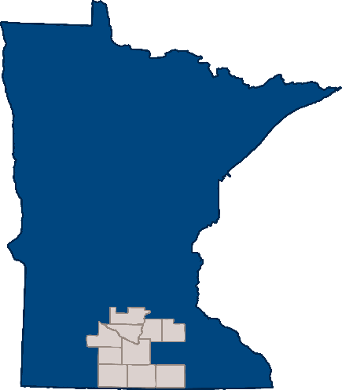
South Central Community Based Initiative
Joint Powers Board Meeting Minutes
3/15/2024

Location: Click or tap here to enter text.
Attendance
Voting: ☒Anne Broskoff, Brown County ☒Phil Claussen, Blue Earth County
☒Chera Sevcik, Faribault/Martin County ☒Suzi Nerison, Freeborn County
☒Jamie Hayes, Le Sueur County ☒Cassie Sassenberg, Nicollet County ☒Megan Thomas, Rice County
☒Klea Rettman, Sibley County ☒Amy Pluym, Watonwan County
Non-voting: ☒Angela Youngerberg, Blue Earth County (Delegate)
☒Anna Garbers, Faribault/Martin County (Delegate) ☒Chris Sammon, Rice County (Delegate)
☒Amy Haas, Consumer Representative ☒Ricki Pribyl, Regional Manager
☒RMT Representative: Pat Rentz via Zoom
☒Children’s Cabinet Representative: Julie Stevermer
Others present: Horizon Homes Staff (partial meeting): Tim Pribyl, Jodi Mundt, Tina Olson, Abby Malterer
Attendance Notes: Megan Thomas via Zoom from 320 NW 3rd St, Faribault, MN

Agenda and notes
Roll Call
Minutes
- Approval of February Meeting Minutes
Approval of the Agenda*
Public Comments (Two Minutes)
Horizon Homes- Budget report
Reports
Financial - Ricki
- Vendor reports for February*
Committee Reports-
- RMT
- Children’s Cabinet
- SET
- Executive
Approval of Committee Reports*
Report of the SCCBI Manager- Ricki
- AMHI Reform Workgroup
- Children’s Crisis Residential Update
- Eide Bailly Audit Q4
- Budget Meeting
- Update on App
- Funding for U of M contract
Agenda Items-
- Waseca Co./MN Prairie involvement with Children’s Cabinet
- Satellite Sites for Mobile Crisis- Feedback from counties with sites
- Nicollet county delegate- Cassie
- SWMN Housing Partnership Contract
- May is Mental Health Month
Other Items

Adjourn

Use this template to record motions and voting within your notes:
Motion: Approve Agenda
Made by: Anne Broskoff
Seconded by: Jamie Hayes
Votes:
Anne Broskoff:Yes Phil Claussen: Yes Chera Sevcik: Yes Suzi Nerison: Yes Jamie Hayes: Yes Cassie Sassenberg: Yes Megan Thomas: Yes Klea Rettman: Yes Amy Pluym: Yes
Angela Youngerberg:No Vote Anna Garbers: No Vote Chris Sammon: No Vote
Outcome: Motion Passed

Horizon Homes presented the budget report update.

Ricki presented the vendor reports.
Motion: Approve Vendor reports
Made by: Jamie.
Seconded by Klea.
Votes:
Anne Broskoff:Yes Phil Claussen: Yes Chera Sevcik: Yes Suzi Nerison: Yes Jamie Hayes: Yes Cassie Sassenberg: Yes Megan Thomas: Yes Klea Rettman: Yes Amy Pluym: Yes
Outcome: Motion Passed

RMT report presented by Pat.
RMT is now full, no open seats.
RMT is discussing when Ricki will be getting an assistant. That is the goal for the year.
Amy H stated that RMT wanted clarification about who is allowed to attend stakeholders and 10 county activity.

**Phil left the room, Angie assumed voting role.**
Motion: Adjust some of the participation guidelines around a number of the activities and budgetary lines:
- Each clubhouse determines membership status.
- For the attendance of the 10 county activities the person needs to be a Clubhouse member or SPMI
- Participation in stakeholders is open to SPMI and SMI adults by self-attestation residing in our 10-county area.
Made by: Angela Youngerberg
Seconded by: Anne Broskoff
Votes:
Anne Broskoff:Yes Phil Claussen: Yes Chera Sevcik: Yes Suzi Nerison: Yes Jamie Hayes: Yes Cassie Sassenberg: Yes Megan Thomas: Yes Klea Rettman: Yes Amy Pluym: Yes
Angela Youngerberg:No Vote Anna Garbers: No Vote Chris Sammon: No Vote
Outcome: Motion Passed
**Phil returned to the room**
Julie S gave Children’s Cabinet update.
Ricki gave SET committee update. They were finishing up last minute Stakeholders’ plans.
Executive committee gave an update on the app development.
AMHI workgroup had their first meeting. Main takeaway was that they are not losing funding, getting a small increase.
Eide Bailey audit is still going on.
-Ricki is hoping to get a budget meeting going, a contract is in the works.
-Update of app: Statement of work is in the packet. Invoices need to be submitted to Rice County by 19th. Beta testing can begin as soon as May.
U of M Funding contract
Ucare has an application process, approval does not take long.
Questions arose about MN Prairie and Waseca being on the Children’s Cabinet and what that means when it comes to splitting costs. Are they members or invited guests? Sue will talk with Tara.
Contract for SWMN needs renewal.
Motion: Continue with the contract as it is with the expectation that we will be given the acceptable updated data to follow.
Made by: Phil Claussen
Seconded by: Amy Pluym
Votes:
Anne Broskoff:Yes Phil Claussen: Yes Chera Sevcik: Yes Suzi Nerison: Yes Jamie Hayes: Yes Cassie Sassenberg: Yes Megan Thomas: Yes Klea Rettman: Yes Amy Pluym: Yes
Angela Youngerberg:No Vote Anna Garbers: No Vote Chris Sammon: No Vote
Outcome: Motion Passed
Motion: Adjourn
Made by: Anne Broskoff
Seconded by: Jamie Hayes
Votes:
Anne Broskoff:Yes Phil Claussen: Yes Chera Sevcik: Yes Suzi Nerison: Yes Jamie Hayes: Yes Cassie Sassenberg: Yes Megan Thomas: Yes Klea Rettman: Yes Amy Pluym: Yes
Angela Youngerberg:No Vote Anna Garbers: No Vote Chris Sammon: No Vote
Outcome: Motion Passed

